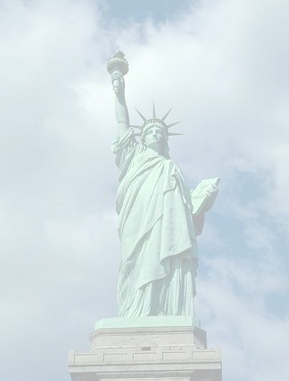
American Society of Hispanic Psychiatry
Annual Symposium
May 5, 2018
Mental Health and Migration
Sheraton Times Square, Madison Square, Lower Lobby
811 7th Avenue
New York, NY 10019

1:00 p.m. Welcome and Introductions
Carlos Zarate, MD and Bernardo Ng, MD
1:15 p.m. Opening Symposium – Mental Health Impact of Immigration Environment in the US
Andrés Pumariega, MD, Eugenio Rothe, MD, William Arroyo, MD

2:30 p.m. TMS and Depressive Symptoms Mexican Experience
Thelma Sanchez, MD

2:50 p.m. Suicidal Behavior Among Adolescents in then Colombian Jungle
Nancy Colimon, MD

3:10 p.m. Clozapine for Children and Adolescents with Conduct Disorder: a Double Blind Clinical Trial
Myrthala Juarez-Trevino, MD

3:30 p.m. BREAK

3:40 p.m. Narcissistic Personality and Bipolar Disorder: Case Report and Literature Review
Mauricio Salvador Garza-Villalobos, MD

4:00 p.m. Sociopathy: A Sample from Mexico City
Nicolas Martinez, MD

4:20 p.m. Discussion and Feedback to Researchers
Ruby Castilla, MD, Carlos Zarate, MD, Juan Gallego, MD and Alvaro Camacho, MD

4:50 p.m. BREAK

5:00 p.m. Short Film “Taina:” Empowering Young People to Express their Cultural Formulations in First-Episode Psychosis Care
Oscar Jimenez-Solomon, MPH, Lic.Soc

5:20 p.m. Two Decades of Research on Transnational Migration Between Mexico and the United States and Substance Abuse
Sergio Aguilar-Gaxiola, MD

6:20 p.m. Closing Remarks/Group Photo
Bernardo Ng, MD

6:40 p.m. Reception – Sheraton Times Square, Madison Suite 2 – 5th Floor

Accreditation Statement
This activity has been planned and implemented in accordance with the accreditation requirements and policies of the Accreditation Council for Continuing Medical Education through the joint providership of the American Psychiatric Association (APA) and the American Society of Hispanic Psychiatry. The APA is accredited by the ACCME to provide continuing medical education for physicians.
Designation Statement
The APA designates this live activity for a maximum of 5 AMA PRA Category 1 Credit ™. Physicians should claim only the credit commensurate with the extent of their participation in the activity.
DISCLOSURES
Planning Committee: Disclosure of financial interest(s) or affiliation(s):
Dr. William Arroyo, MD Nothing to disclose
Dr. Ruby Castilla, MD* Employee; Janssen, pharmaceutical companies of Johnson and Johnson
Dr. Juan Gallego, MD* Nothing to disclose
Dr. Nicholas Martinez, MD Nothing to disclose
Dr. Bernardo Ng, MD Nothing to disclose
Dr. Thelma Sanchez, MD Nothing to disclose
Dr. Carlos Zarate, MD* Co-inventor on a patent for the use of ketamine and its metabolites in the treatment of depression, anxiety, anhedonia, suicidal ideation and post-traumatic stress disorders

Faculty:
Dr. Sergio Aguilar-Gaxiola, MD Nothing to disclose
Dr. Alvaro Camacho, MD Nothing to disclose
Dr. Nancy Colimon, MD Nothing to disclose
Dr. Mauricio S. Garza-Villalobos, MD Nothing to disclose
Dr. Oscar Jimenez-Solomon, PhD Nothing to disclose
Dr. Myrthala Juarez-Trevino, MD Nothing to disclose
Dr. Andres Pumariega, MD Nothing to disclose
Dr. Eugenio Rothe, MD Nothing to disclose

*Designates both planner and faculty

PHYSICIAN CME CERTIFICATES
At the conclusion of the conference, physician participants will be provided with an opportunity to claim hours of participation and receive an official CME certificate by completing the online CME conference evaluation.
1. Go to http://apapsy.ch/ashp-ny
- Click "Access Activity" and log in with your APA username and password or create a new account.
3. Enter the Group ID ASHP181 on the Purchase page and click "Submit" to proceed to the evaluation and certificate. Select "AMA PRA Category 1 Physician" as your certificate type.
You must claim your CME credit within 60 days of the conference. Certificates will not be issued after July 5, 2018. For customer support, please email apalms@psych.org.
CERTIFICATE OF ATTENDANCE FOR NON-PHYSICIANS
Non-physician participants will have the opportunity to receive a certificate of attendance. At the conclusion of the conference, participants should complete the online conference evaluation at http://apapsy.ch/ashp-ny in order to print a certificate of attendance. Follow the instructions above, but select "Certificate of Participation" as your certificate type.

